Mathinator

Software Architecture Document

Version <1.1>

Revision History

|  |  |  |  |
| --- | --- | --- | --- |
| **Date** | **Version** | **Description** | **Author** |
| <28/11/2016> | <1.0> | <Creation of the SAD> | <Lamm, Hug, Saupp> |
| <27/12/2016> | <1.1> | <Adapt the Technology + Database Diagram> | <Lamm, Hug, Saupp> |
|  |  |  |  |
|  |  |  |  |

Table of Contents

1. Introduction 4

1.1 Purpose 4

1.2 Scope 4

1.3 Definitions, Acronyms, and Abbreviations 4

1.4 References 4

1.5 Overview 4

2. Architectural Representation 5

3. Architectural Goals and Constraints 5

4. Use-Case View 5

5. Logical View 6

6. Process View 6

7. Deployment View 6

8. Implementation View 6

9. Data View (optional) 6

10. Size and Performance 6

11. Quality 6

Software Architecture Document

# Introduction

## Purpose

This document provides a comprehensive architectural overview of the system, using a number of different architectural views to depict different aspects of the system. It is intended to capture and convey the significant architectural decisions which have been made on the system.

## Scope

The scope of this SAD is to provide the architecture of the Mathinator project. Affected are the class structure, our use-cases and the

## Definitions, Acronyms, and Abbreviations

## References

|  |  |
| --- | --- |
| **Document** | **Where to find?** |
| Blog | [https://mathinator.tobiaslamm.de](https://mathinator.tobiaslamm.de/) |
| Github | <https://github.com/SaschaHug/Mathinator> |
| Use Case 1 “take a picture” | <https://github.com/SaschaHug/Mathinator/blob/master/1_UC_Mathinator_Take_A_Picture.pdf> |
| Use Case 2 “view history” | <https://github.com/SaschaHug/Mathinator/blob/master/2_UC_Mathinator_View_History.pdf> |
| Use Case 3 “show tour on first start” | <https://github.com/SaschaHug/Mathinator/blob/master/3_UC_Mathinator_Delete_Entry.pdf> |
| Use Case 4 “enable user to delete entries” | <https://github.com/SaschaHug/Mathinator/blob/master/4_UC_Mathinator_Use_Manual_Calculator.pdf> |
| Use Case 5 “do manual calculations” | <https://github.com/SaschaHug/Mathinator/blob/master/5_UC_Mathinator_Show_tour.pdf> |

## Overview

The rest of the document is separated into ten different chapters.

Chapter 2 will describe what software architecture is for the current system, and how is represented. Chapter 3 will cover the software requirements and objectives that have some significant impact on the architecture. Chapter 4 lists use cases/scenarios from the use-case model which have significant impact on the architecture itself. Chapter 5 describes the architecturally significant parts of the design model, such as its parts Controller and Model. Chapter 9 is a description of the persistent data storage perspective of the system.

# Architectural Representation

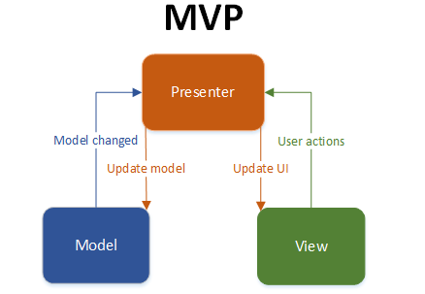

# Architectural Goals and Constraints

In Android you don't have MVC, but you have the following:

* You define your [user interface](https://developer.android.com/guide/topics/ui/index.html) in various XML files by resolution, hardware, etc.
* You define your [resources](https://developer.android.com/reference/android/content/res/Resources.html) in various XML files by locale, etc.
* You extend clases like [ListActivity](https://developer.android.com/reference/android/app/ListActivity.html), [TabActivity](https://developer.android.com/reference/android/app/TabActivity.html) and make use of the XML file by [inflaters](https://developer.android.com/reference/android/view/LayoutInflater.html).
* You can create as many classes as you wish for your business logic.
* A lot of [Utils](https://developer.android.com/reference/android/util/package-summary.html) have been already written for you - DatabaseUtils, Html.

# Use-Case View

n/a

# Logical View

C:\Users\Edeka\Downloads\TechnologyDiagram.png

Description

# Process View

n/a

# Deployment View

n/a

# Implementation View

n/a

# Data View (optional)

To be determined

# Size and Performance

n/a

# Quality

n/a